**Chapter 1:**

1. Types of Computer-Based Information Systems

* An information system that uses computer technology to perform some or all of its intended tasks is called computer based information system.

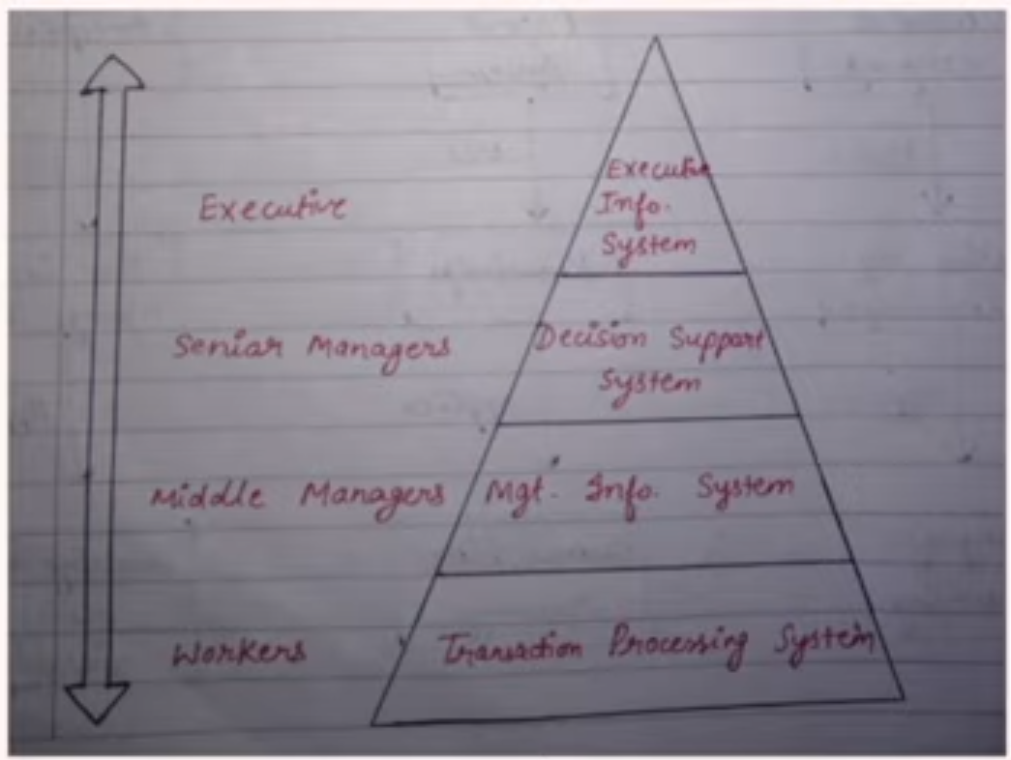

* **Transaction Processing Systems (TPS)**
* collects, stores, modifies, and retrieves the transactions of an organization.
* "transaction" refers to any event that generates or modifies data stored in an information system.
* The primary purpose of a TPS is to record and process routine daily transactions essential to the conduct of business, such as sales, receipts, deposits, withdrawals, etc.
* Example: Payroll systems, billing systems, point of sale systems in retail stores.
* Usually operated by frontline workers, which provide the key data required to support the management of operations.
* Used for both internal and external activities.
* Gives rapid response, is reliable and inflexible.
* **Management Information System (MIS)**
* organizations to transform data into useful information that can support decision-making among managers and other decision-makers
* MIS is focused on the internal sources of information and typically integrates data from various functional sectors of an organization, such as sales, inventory, human resources, and finance.
* The primary purpose of an MIS is to improve the efficiency of managerial activities by providing timely, accurate, and relevant information to managers, thus facilitating informed decision-making.
* It is integrated, structures, flexible and time oriented
* Summarizes and reports on the organization's basic operations using data supplied by TPS.
* **Example:** Sales management systems, inventory control, budgeting systems.
* **Decision Support System (DSS)**
* It's a computer-based system intended to help managers, decision-makers, and professionals make better decisions by using data, analytical models, and decision-making processes.
* DSS is designed to assist in solving complex, non-routine, and semi-structured problems.
* The main purpose of a DSS is to provide support, not to replace managerial judgment.
* It enhances the decision-making process by providing relevant information, analytical tools, or modeling capabilities that can help decision-makers comprehend and solve problems.
* It is interactive, adaptable and supportive.
* Interactive, user-friendly interface, often uses data from both TPS and MIS, incorporates analytical models and data analysis tools.
* **Example:** What-if analysis tools, spreadsheet modeling, business simulations.
* **Executive Information System (EIS)**
* It is also known as Executive Support System (ESS).
* It's a specialized information system tailored to support the information and decision-making needs of senior executives and top-level management.
* EIS provides rapid access to critical and summarized information, often sourced from vast amounts of data, in an easily understandable and often graphical format.
* The primary purpose of an EIS is to provide top-level executives with a quick and comprehensive overview of the entire organization's performance and its external environment.
* It assists them in making strategic decisions, spotting problems, identifying opportunities, and formulating long-term objectives.
* It has a user-friendly interface, uses graphical displays, it interactive and gives real time access.
* Highly user-friendly interfaces, often offers drill-down capabilities, provides access to both internal and external data.
* **Example:** Dashboard tools providing a graphical summary of organizational performance metrics.

1. What is Information System?

* An Information System (**IS**) collects, processes, stores, analyzes, and disseminates information for a specific purpose.
* An information system (IS) is a coordinated collection of resources, including people, processes, data, and technology, that organizations or businesses use to gather, process, store, and distribute information to facilitate decision-making, coordination, and control.
* The purpose of information systems has been defined as getting the right information to the right people, at the right time, in the right amount, and in the right format.
* Information systems are intended to supply useful information.
* Information systems contain information about significant people, places, and things within the organization or in the environment surrounding it.
* By information we mean data that have been shaped into a form that is meaningful and useful to human beings.
* Data, in contrast, are streams of raw facts.

1. Types of Organizational Information Systems

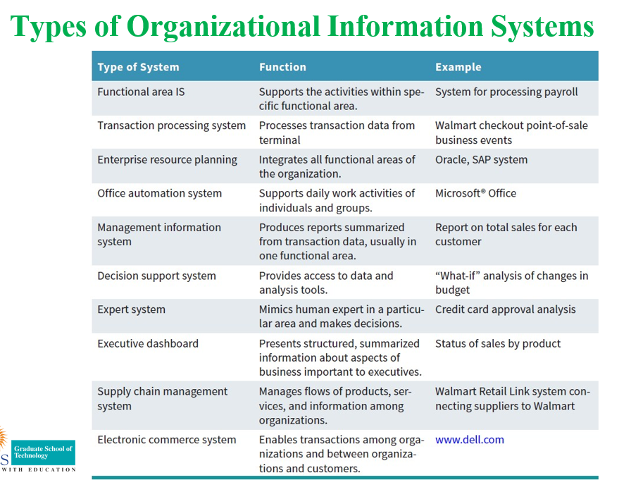

1. Impact of IT in Organisation

The impact of Information Technology (IT) on organizations has been profound, revolutionizing how businesses operate and compete. For the majority of organizations, if their ISs fail, they cease operations until the problems are found and fixed. Industries including book industry, music industry, video industry, software industry, videogame industry, photography industry, marketing industry etc. are impacted by IT.

Here are ten points highlighting the impact of IT on organizations:

1. **Operational Efficiency:** Automation of routine tasks, from data entry to advanced manufacturing processes, has significantly increased efficiency, reducing operational costs and human errors.
2. **Globalization:** IT has facilitated global communication and collaboration, allowing businesses to operate and compete in a global market, source talent from across the world, and serve customers in any location.
3. **Real-time Data Access:** Organizations can access data in real-time, allowing for faster decision-making, immediate feedback, and the ability to quickly respond to market changes or operational challenges.
4. **Customer Relationships:** With the advent of Customer Relationship Management (CRM) systems, businesses can better track and understand customer behavior, tailoring offerings to individual customer needs and improving customer service.
5. **Innovation in Products and Services:** IT has paved the way for innovative products and services, from cloud solutions to mobile applications, creating new revenue streams and business models.
6. **Supply Chain Management:** IT enhances supply chain visibility and coordination, reducing inventory costs, improving procurement strategies, and ensuring timely delivery of products and services.
7. **Remote Work and Flexibility:** Advanced IT infrastructure supports telecommuting and remote work, providing employees with flexibility and enabling organizations to function seamlessly in events like the COVID-19 pandemic.
8. **Knowledge Management:** IT systems allow for the efficient capture, storage, and sharing of knowledge across the organization, leading to informed decision-making and capitalizing on organizational expertise.
9. **Security and Risk Management:** While IT introduces new risks, it also offers advanced tools and systems for cybersecurity, data protection, and risk management, ensuring business continuity and protection against threats.
10. **Improved Communication:** Tools like emails, video conferencing, and collaborative platforms have transformed organizational communication, making it quicker and more effective, bridging geographical and time barriers.

While IT brings transformative benefits to organizations, it also introduces challenges such as the need for continuous upskilling, concerns about privacy, and the potential for technological obsolescence. Nonetheless, embracing IT is essential for modern organizations to thrive in a rapidly evolving business landscape.

1. Describe the importance of Information System to society.

The importance of Information Systems (IS) to society is vast and multifaceted. IS has not only transformed businesses but also significantly impacted societal norms, practices, and daily life. Here are five ways in which Information Systems are crucial to society:

1. **Enhanced Communication:**

**Description**: Information Systems have revolutionized the way people communicate. With tools like email, social media, and instant messaging, communication is now faster, more efficient, and often borderless.

**Impact**: This instant and global communication capability has enabled stronger connections between individuals, bridged cultural gaps, facilitated social movements, and allowed for real-time news dissemination.

1. **Access to Information and Knowledge:**

**Description**: Through the internet and various digital platforms, a vast amount of information on nearly any subject is available at one's fingertips.

**Impact**: This democratization of information has led to a more informed society, where self-education, research, and fact-checking are more accessible than ever. It also plays a crucial role in lifelong learning and professional development.

1. **Economic Opportunities and Job Creation:**

**Description**: Information Systems have given rise to entirely new industries, from e-commerce to digital marketing to app development.

**Impact**: Many jobs today didn't exist a couple of decades ago. IS has created economic opportunities, enabling entrepreneurship, remote work, freelance opportunities, and new career paths, leading to economic growth and diversification.

1. **Improved Public Services and Governance:**

**Description**: Governments and public service organizations utilize Information Systems to offer e-governance solutions, online public services, and digital platforms for citizen engagement.

**Impact**: This has led to more transparent, efficient, and user-friendly services for citizens, reduced bureaucratic hurdles, and fostered a platform for citizen feedback and participation in governance.

1. **Healthcare and Well-being:**

**Description**: Information Systems play a vital role in modern healthcare through Electronic Health Records (EHRs), telemedicine, and health information exchanges.

**Impact**: This has transformed patient care, diagnostics, and treatment. Patients can receive medical consultations without visiting clinics, and medical professionals can access patient records instantly, leading to faster and more accurate treatments.

While the importance of Information Systems in society is undeniable and overwhelmingly positive, it also comes with challenges. Concerns over privacy, cybersecurity, and digital divides (where portions of the population lack access to digital resources) are issues society must address as our reliance on Information Systems grows.

1. Can the terms data, information, and knowledge have different meanings for different people? Support your answer.

Yes, the terms data, information, and knowledge can indeed have different meanings for different people, depending on context, perspective, and application. Let's break this down in simple terms:

1. **Data:**

General Meaning: Raw facts or figures without context. Like individual numbers or isolated words.

Different Interpretations: For a mathematician, data might be numbers used for calculations. For a photographer, data might refer to the pixels in an image.

1. **Information:**

General Meaning: When data is processed and given context, it becomes information. It's more organized than mere data. For example, data arranged in a table can be read as information.

Different Interpretations: To a student, information might mean the content of a textbook chapter. To a weather forecaster, it might mean the prediction for tomorrow's weather based on various data points.

1. **Knowledge:**

General Meaning: When information is absorbed, understood, and can be applied in practical scenarios, it becomes knowledge. It's about understanding and insight.

Different Interpretations: For a chef, knowledge might mean knowing how different ingredients interact. For a doctor, it might mean understanding symptoms to diagnose a disease.

**Why the differences in interpretation?**

**Background and Profession:** Different professions prioritize different kinds of data, information, and knowledge. What's relevant data to a biologist might be irrelevant to an economist.

**Cultural and Societal Differences:** How people perceive information or what they consider as knowledge might differ across cultures.

**Personal Experiences:** Individual experiences can shape what one sees as relevant information or valuable knowledge.

In essence, while these terms have broad general definitions, their specifics can vary based on who you're asking and in what context they're thinking.

1. Describe Porter’s value chain model. Differentiate between Porter’s competitive forces model and his value chain model.

**Porter’s Value Chain Model:**

* Michael Porter introduced the concept of the value chain in his book "Competitive Advantage" in 1985.
* The value chain model describes how businesses receive raw materials, add value to the raw materials through various processes, and sell finished products.
* It's a way to look at how competitive advantage is created in the activities that an organization performs.
* Used to identify specific activities where they can use competitive strategies for greatest impact.
* The value chain model identifies points where an organization can use IT to achieve competitive advantage.
* Activities divided into two categories: **Primary Activities** and **Support Activities. Primary Activities** add value directly to the firm’s products or services. **Support Activities** contribute to the firm’s competitive advantage by supporting the primary activities.

**Chapter 2:**

1. Discuss ways that common challenges in managing data can be addressed using data governance.

**The Difficulties of Managing Data**

1. The amount of data increases exponentially with time.(Walmart have to manage petabytes of data)
2. Data are also scattered throughout organizations, and they are collected by many individuals using various methods and devices. These data are frequently stored in numerous servers and locations and in different computing systems, databases, formats, and human and computer languages.
3. Data are generated from multiple sources.(Internal, External, Personal)
4. Data also come from the Web, in the form of clickstream data. Clickstream data are those data that visitors and customers produce when they visit a Web site and click on hyperlinks. Clickstream data provide a trail of the users’ activities in the Web site, including user behavior and browsing patterns.
5. Data degrade over time. For example, customers move to new addresses or change their names, companies go out of business or are bought, new products are developed, employees are hired or fired, and companies expand into new countries.
6. Over time, temperature, humidity, and exposure to light- Cause physical problems with storage media & its difficult to access the data.

**Data Governance**

* An approach to managing information across an entire organization.
* The objective is to make information available, transparent, and useful for the people who are authorized to access it, from the moment it enters an organization until it is outdated and deleted.

**Strategies for implementing Data Governance**

* **Master Data Management** is a process that spans all organizational business processes and applications. It provides companies with the ability to store, maintain, exchange, and synchronize a consistent, accurate, and timely “single version of the truth” for the company’s master data.
* **Master data -** set of core data, such as customer, product, employee, vendor, geographic location, and so on, that span the enterprise information systems.
* **Transaction data** - generated and captured by operational systems, describe the business’s activities, or transactions.
* **Master data** are applied to multiple transactions and are used to categorize, aggregate, and evaluate the transaction data.

1. Define Big Data and its basic characteristics.

Big Data as diverse, high-volume, high velocity information assets that require new forms of processing to enable enhanced decision making, insight discovery, and process optimization.

Second The Big Data Institute

defines Big Data as vast datasets that:

* Exhibit variety; Include structured, unstructured, and semi-structured data;
* Are generated at high velocity with an uncertain pattern;
* Do not fit neatly into traditional, structured, relational databases; and
* Can be captured, processed, transformed, and analyzed in a reasonable amount of time only by sophisticated information systems.

**Characteristics of Big Data**

1. **Volume** — the size and amounts of big data that companies manage and analyze. For instance Sensors in a single jet engine can generate 10 terabytes of data in 30 minutes. With more than 25,000 airline flights per day, the daily volume of data from just this single source is very huge.
2. **Velocity**—the speed at which companies receive, store and manage data. The rate of data flow into an organization is rapidly increasing. It increases the speed of the feedback loop between a company, its customers, its suppliers, and its business partners.
3. **Variety**—the diversity and range of different data types, including unstructured data, semi-structured data and raw data. Big Data formats change rapidly. They include satellite imagery, broadcast audio streams, digital music files, Web page content, scans of government documents, and comments posted on social networks.
4. **Veracity** — It refers to the quality and accuracy of data. Gathered data could have missing pieces, may be inaccurate or may not be able to provide real, valuable insight. Veracity, overall, refers to the level of trust there is in the collected data.
5. **Value**— value that big data can provide, and it relates directly to what organizations can do with that collected data.
6. Describe the benefits and challenges of implementing knowledge management systems in organizations

Knowledge Management Systems (KMS) play a pivotal role in modern organizations, enabling them to harness and leverage the collective expertise and knowledge of their employees. Here are the benefits and challenges associated with implementing Knowledge Management Systems:

**Benefits of Implementing Knowledge Management Systems:**

1. Improved Decision Making: With a consolidated repository of information and insights, decision-makers can make more informed choices based on historical data, best practices, and expert advice.
2. Increased Efficiency: Reduces the time employees spend searching for information, as they can access knowledge bases, previous project templates, or solutions to problems encountered before.
3. Facilitation of Innovation: By fostering a culture of knowledge sharing, organizations can encourage new ideas, innovation, and collaborative problem solving.
4. Avoiding Redundancy: Helps in preventing duplication of efforts. When employees are aware of work done previously within the organization, they can build upon existing knowledge rather than starting from scratch.
5. Preserving Institutional Knowledge: Prevents loss of knowledge due to employee turnover. Expertise and insights remain within the organization even if key individuals leave.
6. Enhancing Customer Service: With a robust KMS, customer service representatives can quickly access solutions to common problems, product information, and previous customer interactions, leading to improved service quality.

**Challenges of Implementing Knowledge Management Systems:**

1. Cultural Resistance: Employees might resist sharing knowledge, either due to concerns about job security or because they view knowledge as a personal asset that gives them a competitive edge.
2. Data Overload: Without proper curation and organization, a KMS can become cluttered with redundant or obsolete information, making it hard to find relevant content.
3. Maintaining Up-to-Date Information: Knowledge evolves, and the system requires regular updates. Ensuring that the content remains current and accurate can be resource-intensive.
4. Integration with Other Systems: Integrating a KMS with other organizational systems (like CRM, ERP) might pose technical challenges, especially if different software solutions are not compatible.
5. Security Concerns: As with any system storing valuable data, there's a risk of data breaches. Organizations need to ensure that their KMS is secure, and only authorized individuals can access sensitive information.
6. High Initial Costs: The process of setting up a comprehensive KMS, training employees, and integrating it with other organizational tools can be expensive and time-consuming.

In conclusion, while Knowledge Management Systems offer a range of benefits that can enhance organizational performance and competitiveness, successful implementation requires addressing various challenges, especially around culture, technology integration, and security.

**Challenges to Implement (ppt)**

1. Employees must be willing to share their personal tacit knowledge. To encourage this behavior, organizations must create a knowledge management culture that rewards employees who add their expertise to the knowledge base.

2. The organization must continually maintain and upgrade its knowledge base.(incorporate new knowledge and delete old, outdated knowledge)

3. Companies must be willing to invest in the resources needed to carry out these operations

1. Describe how companies can use Big Data to gain competitive advantage.

Big Data, characterized by its volume, variety, velocity, and veracity, provides companies with unique opportunities to derive insights and improve operations. Here's how companies can leverage Big Data to gain a competitive advantage:

**Customer Insights and Personalization:**

* Analyzing customer data can help companies understand purchasing behaviors, preferences, and trends.
* With these insights, companies can offer personalized product recommendations, tailor marketing campaigns, or develop products/services that better align with customer needs.

**Operational Efficiency:**

* By analyzing data from operations, companies can identify bottlenecks, inefficiencies, or areas of waste in their processes.
* For instance, in manufacturing, Big Data analytics can optimize supply chain routes or improve machinery uptime.

**Risk Management and Fraud Detection:**

* Financial institutions can use Big Data to detect unusual patterns or anomalies in transactions, reducing the risk of fraud.
* It also helps in risk assessment, helping companies better understand potential vulnerabilities.

**Product and Service Innovation:**

* By analyzing market trends, customer feedback, and competitor data, companies can identify gaps in the market or emerging needs.
* This leads to the development of innovative products or services that address these needs.

**Optimized Marketing Campaigns:**

* Big Data allows for the analysis of the effectiveness of marketing campaigns in real-time.
* Companies can refine their marketing strategies, allocate budgets more efficiently, and target audiences more precisely.

**Improved Customer Experience:**

* By analyzing customer interactions across various touchpoints (like call centers, social media, and online chats), companies can identify areas for improvement in customer service.
* Predictive analytics can also be used to address customer issues even before they arise.

**Strategic Decision Making:**

* With the vast amount of information available, leadership can make decisions based on data-driven insights rather than relying solely on intuition or traditional methods.

**Supply Chain and Inventory Management:**

* Companies can predict demand more accurately, optimize inventory levels, and streamline vendor interactions, leading to reduced costs and faster delivery times.

**Human Resources and Talent Acquisition:**

* By analyzing employee data, companies can identify the traits of top performers and use this information in recruitment.
* Additionally, predictive analytics can identify potential employee attrition, allowing for proactive retention strategies.

**Monetizing Data:**

* Some companies, especially tech giants, have managed to monetize their data by offering analytics services or selling data insights (while ensuring privacy regulations are adhered to).

To truly harness the competitive advantages offered by Big Data, companies need to invest in the necessary technologies, recruit skilled personnel, and foster a culture of data-driven decision-making. However, it's also crucial to navigate the ethical and privacy concerns associated with the collection and analysis of vast amounts of data.

1. Describe the characteristics of a data warehouse.

A **Data Warehouse** is a repository of historical data that are organized by subject to support decision makers in the organization. Since data warehouses are so expensive, they are used by large companies.

**Basic Characteristics**

1. **Organized by business dimension or subject-** Data are organized by subject—for example, by customer, vendor, product, price level, and region.
2. **Use online analytical processing** - The objectives are speed and efficiency, which are critical to a successful Internet-based business operation. Online analytical processing involves the analysis of accumulated data by end users.
3. **Integrated -** Data are collected from multiple systems and then integrated around subjects. (Customer data)
4. **Time Variant –** Historical data is maintained over the time period. Organizations utilize historical data to detect deviations, trends, and long- term relationships.
5. **Non-volatile**- Data is retained after power loss, users cannot change or update the data. Warehouses and marts are updated, but through IT- controlled load processes rather than by users.
6. **Multidimensional -** Relational databases store data in 2-D tables. In contrast, data warehouses and marts store data in more than 2-D. A common representation for this multidimensional structure is the *data cube*.
7. Phases and process of decision making.

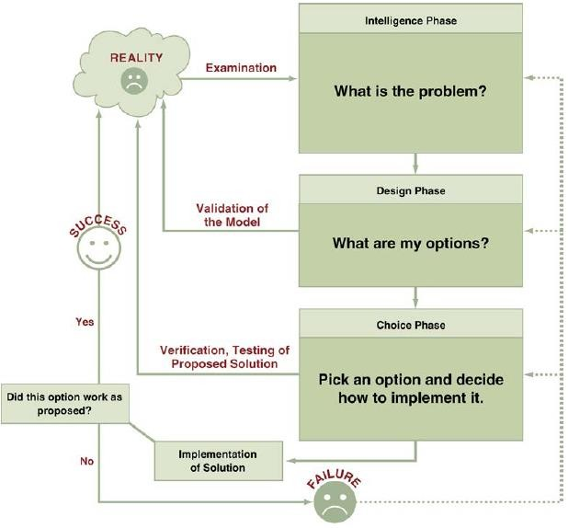

* The decision-making process starts with the *intelligence phase*, in which managers examine a situation and then identify and define the problem or opportunity.
* In the *design phase*, decision makers construct a model for addressing the situation.
* They perform this task by making assumptions that simplify reality and by expressing the relationships among all of the relevant variables.
* Managers then validate the model by using test data.
* Finally, decision makers set criteria for evaluating all of the potential solutions that are proposed.
* The *choice phase* involves selecting a solution or course of action that seems best suited to resolve the problem.
* This solution (the decision) is then implemented.
* Implementation is successful if the proposed solution solves the problem or seizes the opportunity.
* If the solution fails, then the process returns to the previous phases Computer-based decision support assists managers in the decision-making process.

1. Describe the knowledge management system cycle.

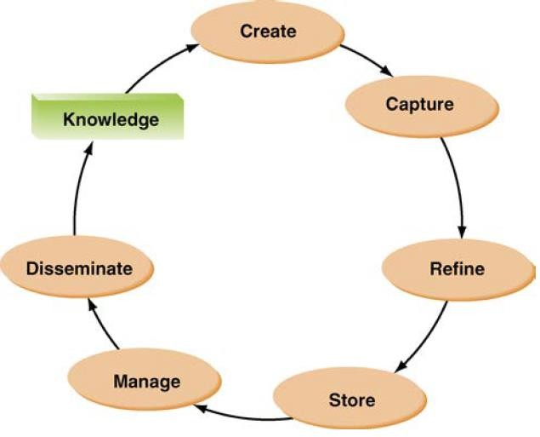

**KMS Cycle**

1. ***Create knowledge***. Knowledge is created as people determine new ways of doing things or develop know-how. Sometimes external knowledge is brought in.
2. ***Capture knowledge***. New knowledge must be identified as valuable and be represented in a reasonable way.
3. ***Refine knowledge***. New knowledge must be placed in context so that it is actionable. This is where tacit qualities (human insights) must be captured along with explicit facts.
4. ***Store knowledge***. Useful knowledge must then be stored in a reasonable format in a knowledge repository so that other people in the organization can access it.
5. ***Manage knowledge***. Like a library, the knowledge must be kept current. It must be reviewed regularly to verify that it is relevant and accurate.
6. ***Disseminate knowledge***. Knowledge must be made available in a useful format to anyone in the organization who needs it, anywhere and anytime
7. Differentiate among descriptive analytics, predictive analytics, and prescriptive analytics.

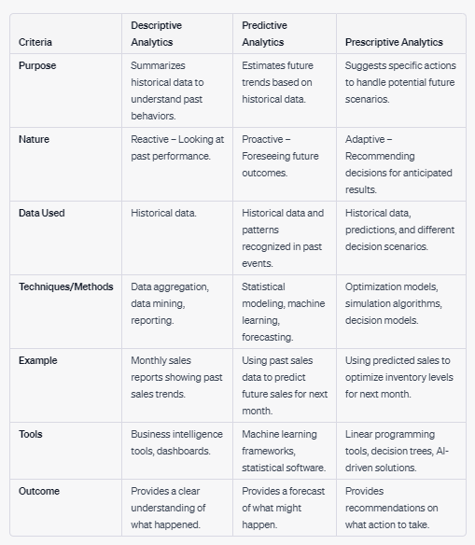

1. Describe each of the various analytics tools and examples of their uses.

There are numerous analytics tools available in the market, each designed for specific tasks, ranging from data visualization to advanced predictive modeling. Here's a breakdown of some popular analytics tools and examples of their uses:

1. Excel:

* Description: A spreadsheet program that offers basic data analytics and visualization features.
* Use Example: Financial analysis, budgeting, creating simple charts, and even basic data cleaning.

1. Tableau:

* Description: A leading data visualization tool that allows users to create interactive and shareable dashboards.
* Use Example: Visualizing sales data across regions, monitoring key performance indicators (KPIs) in real-time dashboards.

1. Power BI:

* Description: Microsoft's data visualization and business intelligence platform.
* Use Example: Analyzing and visualizing customer behavior data to identify trends and insights, then sharing these findings across a company.

1. Google Analytics:

* Description: A web analytics service that tracks website traffic and provides insights into user behavior.
* Use Example: Monitoring website visitors, understanding which marketing campaigns are driving the most traffic, or identifying high-exit webpages.

1. SQL (Structured Query Language):

* Description: A domain-specific language used in programming and managing relational databases.
* Use Example: Querying databases to gather specific datasets, such as sales data from a particular region or time frame.

These tools, among others, enable businesses and researchers to extract insights from their data, drive decision-making, and create value. The best tool often depends on the specific requirements of the task at hand and the expertise of the users.

1. Explain each phase of the business analytics process.

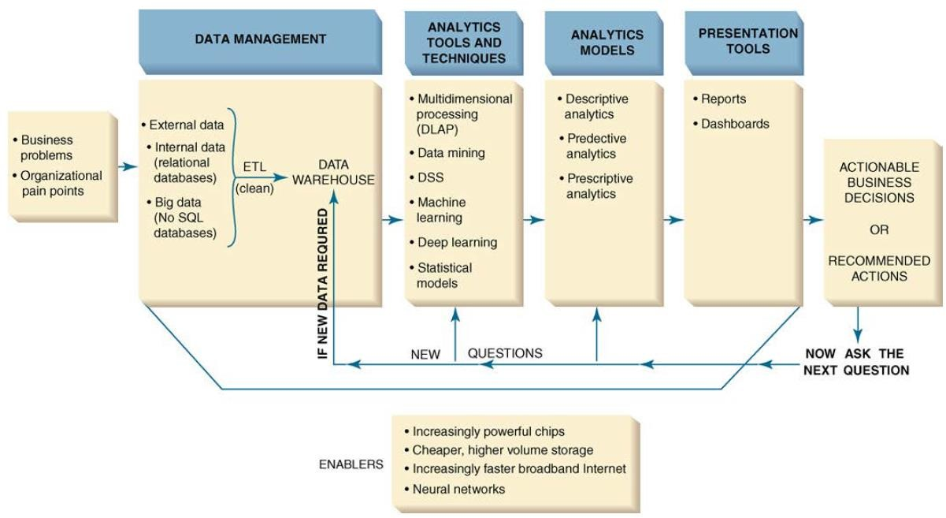

1. Tools of Business Analytics.
2. **Excel:**
   * BI capabilities available in Excel and SharePoint Online. These services enable you to gather data, visualize data, add filters, add advanced analytic capabilities and share information with people in your organization across multiple devices.
3. **Multidimensional Analysis or** **Online Analytical Processing:**
   * also referred as **online analytical** **processing (OLAP)**.
   * it involves “slicing and dicing” data stored in a dimensional format, drilling down in the data to greater detail, and aggregating the data.
4. **Data Mining:**
   * The process of searching for valuable business information in a large database, data warehouse, or data mart.
   * Data mining can perform two basic operations:

* predicting trends and behaviours - ***targeted marketing , forecasting bankruptcy etc.***
* identifying previously unknown patterns - ***analyze retail sales data to discover seemingly unrelated products that people often purchase together.***

1. **Decision Support Systems(DSSs):**

* Combine models and data to analyze semi structured and some unstructured problems that involve extensive user involvement.
* They enable business managers and analysts to access data interactively, to manipulate these data, and to conduct appropriate analyses.
* They can enhance learning and contribute to all levels of decision making.
* DSSs also employ mathematical models.
* Finally, they have the related capabilities of sensitivity analysis, what–if analysis, and goal-seeking analysis, which are useful for any type of DSSs.

**Chapter 3:**

1. Major ethical standards.

There are many sources for ethical standards. The four major standards are as below.

1. ***The utilitarian approach-*** An ethical action provides the most good or does the least harm to customers, employees, shareholders, the community, and the physical environment.
2. ***The rights approach-*** An ethical action best protects and respects the moral rights of the of customers, employees, shareholders, business partners, and even competitors. (Moral rights - the rights to make one’s own choices about what kind of life to lead, to be told the truth, not to be injured, and to enjoy a degree of privacy)
3. ***The fairness approach-*** The ethical actions treat all human beings equally, or, if unequally, then fairly, based on some defensible standard. For example, most people might believe it is fair to pay people.
4. ***The common good approach-*** Believes that Respect and compassion for all others is the basis for ethical actions. It emphasizes the common conditions like a system of laws, effective police and fire departments, healthcare, a public educational system, and even public recreation areas, which are important to the welfare of everyone.
5. Steps in ethical framework.

**Ethical Frameworks**

Combine these four standards, a general framework for ethics (or ethical decision making) is developed. This framework consists of five steps:

1. **Recognize an ethical issue:**

Could this decision or situation damage someone or some group? Does this decision involve a choice between a good and a bad alternative? Does this issue involve more than simply legal considerations? If so, then in what way?

1. **Get the facts:**

What are the relevant facts of the situation? Do I have sufficient

information to make a decision? Which individuals and/or groups have an important stake in the outcome? Have I consulted all relevant persons and groups?

1. **Evaluate alternative actions:**

Which option will produce the most good and do the least harm? Which option best respects the rights of all stakeholders? Which option treats people equally or proportionately? Which option best serves the community as a whole, and not just some members?

1. **Make a decision and test it:**

Considering all the approaches, which option best addresses the

situation?

1. **Act and reflect on the outcome of your decision:**

How can I implement my decision with the greatest care and attention to the concerns of all stakeholders? How did my decision turn out, and what did I learn from this specific situation?

1. Categories of ethical issues.

**Ethical Issues**

A variety of ethical issues exists due to the diversity and ever-expanding use of IT applications.

Four general categories: privacy, accuracy, property, and accessibility.

1. ***Privacy issues*** involve collecting, storing, and disseminating information about individuals.

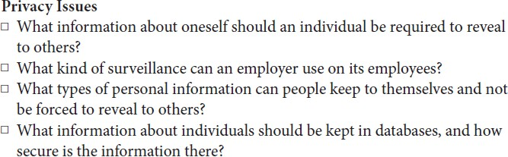

1. ***Accuracy issues*** involve the authenticity, fidelity, and accuracy of information that is collected and processed.

1. ***Property issues*** involve the ownership and value of information.

1. ***Accessibility issues*** revolve around who should have access to information and whether they should have to pay for this access.

